***EMPLOYEE ATTENDANCE MANAGEMENT***

A Mini Project Report

**SUBMITTED BY**

**MOUNAMITHRA.R 230701197**

**MADHUNESHA.G 230701170**

In partial fulfilment for the award of the degree of

BACHELOR OF ENGINEERING

IN

COMPUTER SCIENCE

RAJALAKSHMI ENGINEERING COLLEGE (AUTONOMOUS)

THANDALAM

CHENNAI-602105

2023-2024

**BONAFIDE CERTIFICATE**

Certificate that this project report “EMPLOYEE ATTENDANCE MANAGEMENT” is a bona fide work of “MADHUNESHA G(230701170),MOUNAMITHRA R(230701197)” who carried out the project work under my supervision.

Submitted for the Practical Examination held on _________

SIGNATURE

Mrs.K.Maheshmeena

Assistant Professor

Computer Science and

Engineering

Rajalakshmi Engineering

College(Autonomous)

Chennai-602 105

**Abstract**

**The Employee Attendance Management System is a streamlined solution for managing employee attendance and information. It provides secure login for employees, allowing them to mark attendance and update their details efficiently. The system features a centralized database to store employee records and attendance logs, ensuring easy data retrieval and management.**

**Key operations include adding, editing, and viewing attendance and employee information. The system reduces manual errors, saves time, and improves the accuracy of attendance tracking. Designed with a user-friendly interface, it is ideal for small to medium-sized organizations looking to automate their attendance management process.**

**TABLE OF CONTENTS**

CHAPTER 1: INTRODUCTION………………………………………………………………………..5

1.1) INTRODUCTION……………………………………………………………………………………5

1.2) OBJECTIVE…………………………………………………………………………………………..5

1.3) MODULES……………………………………………………………………………………………5

CHAPTER 2: SURVEY OF TECHNOLOGY…………………………………………………………8

2.1) SOFTWARE DESCRIPTION……………………………………………………………………..8

2.2) PROGRAMMING LANGUAGES……………………………………………………………...8

2.2.1) JavaScript……………………………………………………………………………………8

2.2.2) Python……………………………………………………………………………………….8

2.3) FRAMEWORKS/MODULES USED...............................................................9

2.3.1) FRAMEWORKS USED WITH JAVASCRIPT………………………………………9

2.3.2) MODULES USED IN PYTHON……………………………………………………….9

CHAPTER 3: REQUIREMENTS AND ANALYSIS…………………………………………………10

3.1) REQUIREMENT SPECIFICATIONS…………………………………………………………..10

3.2) HARDWARE SPECIFICATIONS………………………………………………………………..10

3.3) Functional/Non-Functional Requirements……………………………………………11

3.4)ER Diagram…………………………………………………………………………………………..11

CHAPTER 4: Program Code…………………………………………………………………………….12

CHAPTER 5: RESULT……………………………………………………………………………………….13

CHAPTER-6: CONCLUSION………………………………………………………………………………1

**CHAPTER 1: INTRODUCTION**

**1.1)INTRODUCTION:**

The **Brew News Website** is a streamlined platform for managing employee attendance and information. Developed with a **Java-based front end** and **SQL back end**, it ensures an efficient and user-friendly experience.The website features key modules: **Home**, **Edit**, **Info**, **Profile**, and **Login**, allowing employees to log in securely, mark attendance, and update their profiles. It also provides detailed employee information for easy access and management.With robust data storage and retrieval through SQL and an interactive interface powered by Java, this system simplifies attendance tracking and information management, making it ideal for small to medium-scale organizations.

**1.2) OBJECTIVE:**

The objective of the Brew News Website is to create an efficient and interactive system for managing employee attendance and information. The platform aims to simplify attendance tracking, ensure accurate record-keeping, and provide secure login functionality for employees. It enables easy management of employee details, including updates and retrieval, through a user-friendly Java-based front end. The back end, powered by SQL, ensures reliable data storage and quick access, making the system ideal for streamlining organizational processes and reducing manual effort.

**1.3) MODULE:**

🡪Home

🡪Login

🡪Profile

🡪Attendance

🡪Info

🡪Edit

**CHAPTER 3: REQUIREMENTS AND ANALYSIS**

**3.1)**REQUIREMENT SPECIFICATIONS

**User Requirements:**

1. **Secure Login**: Users must log in with valid credentials to access the system.
2. **Attendance Management**: Employees can mark their attendance and view attendance history.
3. **Profile Management**: Users can view and update their personal and professional information.
4. **Information Access**: Employees can access relevant organizational and personal data.
5. **Data Edit Permissions**: Authorized users can edit attendance and employee details.
6. **User-Friendly Interface**: The system should be intuitive and easy to navigate.

**System Requirements**:

The system requires a Java-based front end, an SQL database, a modern web browser, and a minimum of 4GB RAM with 500MB storage. It runs on Windows, Linux, or MacOS and needs JDK and SQL server tools for operation.

3.2)HARDWARE SPECIFICATIONS

Software Requirements:

* **Front-End**: Java
* **Back-End**: SQL Database
* **Development Tools**: JDK, IDE for Java
* **Database Management**: SQL Server tools or MySQL Workbench

System Requirements:

• **Operating System**: Windows, Linux, or MacOS

• **Hardware**: Minimum 4GB RAM, 500MB storage

• **Browser**: Compatible with modern web browsers

• **Software**: JDK, SQL Server/MySQL

**CHAPTER 4:PROGRAM CODE**

import javax.swing.*;

import java.awt.*;

import java.awt.event.*;

public class SignupPage {

    public SignupPage(JFrame loginFrame) {  // Accept login page frame to close it when back is pressed

        JFrame frame = new JFrame("Sign Up Page");

        frame.setSize(400, 300);

        frame.setDefaultCloseOperation(JFrame.EXIT_ON_CLOSE);

        frame.setLocationRelativeTo(null);

        frame.setLayout(new BorderLayout()); // Use BorderLayout for the frame layout

        // Create a panel for the form inputs (username, password, and confirm password)

        JPanel formPanel = new JPanel(new GridLayout(3, 2)); // 3x2 grid layout for form fields

        JTextField usernameField = new JTextField(20);

        JPasswordField passwordField = new JPasswordField(20);

        JPasswordField confirmPasswordField = new JPasswordField(20);

        formPanel.add(new JLabel("Username:"));

        formPanel.add(usernameField);

        formPanel.add(new JLabel("Password:"));

        formPanel.add(passwordField);

        formPanel.add(new JLabel("Confirm Password:"));

        formPanel.add(confirmPasswordField);

        // Add formPanel to the center of the frame

        frame.add(formPanel, BorderLayout.CENTER);

        // Create buttons panel for Sign Up and Back buttons

        JPanel buttonPanel = new JPanel();

        JButton signupButton = new JButton("Sign Up");

        JButton backButton = new JButton("Back");

        // Add buttons to buttonPanel

        buttonPanel.add(signupButton);

        buttonPanel.add(backButton);

        // Add the buttonPanel to the bottom of the frame

        frame.add(buttonPanel, BorderLayout.SOUTH);

        // Action Listener for Sign Up Button

        signupButton.addActionListener(new ActionListener() {

            public void actionPerformed(ActionEvent e) {

                String username = usernameField.getText();

                String password = new String(passwordField.getPassword());

                String confirmPassword = new String(confirmPasswordField.getPassword());

                if (!password.equals(confirmPassword)) {

                    JOptionPane.showMessageDialog(frame, "Passwords do not match!");

                    return;

                }

                JOptionPane.showMessageDialog(frame, "Sign Up Successful!");

                frame.dispose();  // Close the signup page

                new LoginPage();  // Open the login page

            }

        });

        // Action Listener for Back Button

        backButton.addActionListener(new ActionListener() {

            public void actionPerformed(ActionEvent e) {

                frame.dispose();  // Close the signup page

                loginFrame.setVisible(true);  // Show the login page again

            }

        });

        frame.setVisible(true);

    }

}

#MySQL connection

import java.sql.Connection;

import java.sql.DriverManager;

import java.sql.SQLException;

public class MySQLConnection {

    public static void main(String[] args) {

        // Database credentials

        String url = "jdbc:mysql://localhost:3306/EmployeeAttendanceDB";

        String user = "root";  // Change to your MySQL username

        String password = "root";  // Change to your MySQL password

        // Try to connect to the database

        try {

            // Load and register MySQL JDBC driver

            Class.forName("com.mysql.cj.jdbc.Driver");

            // Establish the connection

            Connection connection = DriverManager.getConnection(url, user, password);

            // If connection is successful, print success message

            System.out.println("Connected to the database successfully!");

            // Don't forget to close the connection

            connection.close();

        } catch (SQLException | ClassNotFoundException e) {

            // Handle exceptions

            System.err.println("Error connecting to the database: " + e.getMessage());

        }

    }

}

#login page

import javax.swing.*;

import java.awt.*;

import java.awt.event.*;

public class LoginPage {

    public LoginPage() {

        // Create the Login frame

        JFrame loginFrame = new JFrame("Login Page");

        loginFrame.setSize(400, 200);

        loginFrame.setDefaultCloseOperation(JFrame.EXIT_ON_CLOSE);

        loginFrame.setLocationRelativeTo(null);  // Center the window

        // Create a panel for login form

        JPanel panel = new JPanel();

        panel.setLayout(new GridLayout(3, 2));

        // Add labels and text fields for login

        panel.add(new JLabel("Username:"));

        JTextField usernameField = new JTextField();

        panel.add(usernameField);

        panel.add(new JLabel("Password:"));

        JPasswordField passwordField = new JPasswordField();

        panel.add(passwordField);

        // Login button

        JButton loginButton = new JButton("Login");

        panel.add(loginButton);

        // Add the panel to the frame

        loginFrame.add(panel, BorderLayout.CENTER);

        // Action Listener for Login Button

        loginButton.addActionListener(new ActionListener() {

            public void actionPerformed(ActionEvent e) {

                // Simulate successful login (you can replace this with actual login logic)

                JOptionPane.showMessageDialog(loginFrame, "Login successful!");

                // Dispose of the login frame and open HomePage

                loginFrame.dispose();

                new HomePage();  // Open HomePage after successful login

            }

        });

        // Make the frame visible

        loginFrame.setVisible(true);

    }

    public static void main(String[] args) {

        // Start the LoginPage when the program runs

        new LoginPage();

    }

}

#Home Page

import javax.swing.*;

import java.awt.*;

import java.awt.event.*;

public class HomePage {

    public HomePage() {

        // Create the Home Page frame

        JFrame homeFrame = new JFrame("Home Page");

        homeFrame.setSize(500, 300); // Slightly larger frame for better spacing

        homeFrame.setDefaultCloseOperation(JFrame.EXIT_ON_CLOSE);

        homeFrame.setLocationRelativeTo(null); // Center the window

        // Create a label to display a welcome message

        JLabel label = new JLabel("Welcome to the Home Page", SwingConstants.CENTER);

        label.setFont(new Font("Arial", Font.BOLD, 18)); // Set label font style

        homeFrame.add(label, BorderLayout.NORTH); // Add label to the top of the frame

        // Create a panel for buttons

        JPanel buttonPanel = new JPanel();

        buttonPanel.setLayout(new FlowLayout());  // Set layout to FlowLayout for horizontal arrangement

        // Create buttons

        JButton homeButton = new JButton("Home");

        JButton editButton = new JButton("Edit");

        JButton infoButton = new JButton("Info");

        JButton profileButton = new JButton("Profile");

        // Add buttons to the buttonPanel

        buttonPanel.add(homeButton);

        buttonPanel.add(editButton);

        buttonPanel.add(infoButton);

        buttonPanel.add(profileButton);

        // Add the buttonPanel to the top of the frame (instead of bottom)

        homeFrame.add(buttonPanel, BorderLayout.NORTH);  // Changed from SOUTH to NORTH

        // Action Listener for Home Button

        homeButton.addActionListener(new ActionListener() {

            public void actionPerformed(ActionEvent e) {

                JOptionPane.showMessageDialog(homeFrame, "You are already on the Home Page!");

            }

        });

        // Action Listener for Edit Button

        editButton.addActionListener(new ActionListener() {

            public void actionPerformed(ActionEvent e) {

                // Open the EditPage when Edit Button is clicked

                new EditPage();  // Create an instance of EditPage

                homeFrame.dispose();  // Close the HomePage

            }

        });

        // Action Listener for Info Button

        infoButton.addActionListener(new ActionListener() {

            public void actionPerformed(ActionEvent e) {

                // Open the InfoPage when the Info Button is clicked

                new InfoPage(homeFrame);  // Pass the homeFrame to InfoPage so we can return to it

                homeFrame.setVisible(false);  // Hide the HomePage

            }

        });

        // Action Listener for Profile Button (Launch ProfilePage)

        profileButton.addActionListener(new ActionListener() {

            public void actionPerformed(ActionEvent e) {

                // Open the ProfilePage when Profile Button is clicked

                new ProfilePage(homeFrame);  // Create an instance of ProfilePage

            }

        });

        // Create a Logout button (to be positioned at bottom-right)

        JButton logoutButton = new JButton("Logout");

        // Panel to hold the logout button

        JPanel logoutPanel = new JPanel();

        logoutPanel.setLayout(new BorderLayout());  // Use BorderLayout to position the button

        logoutPanel.add(logoutButton, BorderLayout.EAST); // Position the logout button on the right

        // Action Listener for Logout Button

        logoutButton.addActionListener(new ActionListener() {

            public void actionPerformed(ActionEvent e) {

                // Dispose of the HomePage frame

                homeFrame.dispose();

                // Open the LoginPage (you need to implement this)

                new LoginPage();  // Assuming you have a LoginPage class

            }

        });

        // Add the logoutPanel to the bottom of the frame

        homeFrame.add(logoutPanel, BorderLayout.SOUTH);

        // Make the frame visible

        homeFrame.setVisible(true);

    }

    public static void main(String[] args) {

        // Start the HomePage when the program runs

        new HomePage();

    }

}

#Edit

import javax.swing.*;

import java.awt.*;

import java.awt.event.*;

public class EditPage {

    public EditPage() {

        // Create the Edit Page frame

        JFrame editFrame = new JFrame("Edit Page");

        editFrame.setSize(400, 300); // Increase size to fit all components

        editFrame.setDefaultCloseOperation(JFrame.EXIT_ON_CLOSE);

        editFrame.setLocationRelativeTo(null); // Center the window

        // Create a label to display a message

        JLabel label = new JLabel("Choose an option", SwingConstants.CENTER);

        label.setFont(new Font("Arial", Font.BOLD, 16)); // Set label font style

        editFrame.add(label, BorderLayout.NORTH); // Add label to the top of the frame

        // Create a panel for buttons

        JPanel buttonPanel = new JPanel();

        buttonPanel.setLayout(new FlowLayout());  // Set layout to FlowLayout for horizontal arrangement

        // Create buttons

        JButton registerButton = new JButton("Register");

        JButton attendanceButton = new JButton("Attendance");

        // Add buttons to the buttonPanel

        buttonPanel.add(registerButton);

        buttonPanel.add(attendanceButton);

        // Add the buttonPanel to the center of the frame

        editFrame.add(buttonPanel, BorderLayout.CENTER);

        // Create a Back button and place it at the bottom

        JButton backButton = new JButton("Back");

        editFrame.add(backButton, BorderLayout.SOUTH);

        // Action Listener for Register Button

        registerButton.addActionListener(new ActionListener() {

            public void actionPerformed(ActionEvent e) {

                // Open RegisterPage when the Register button is clicked

                new RegisterPage(); // Open RegisterPage

                editFrame.dispose(); // Close the EditPage frame

            }

        });

        // Action Listener for Attendance Button

        attendanceButton.addActionListener(new ActionListener() {

            public void actionPerformed(ActionEvent e) {

                // Open EditEmployeeAttendancePage when the Attendance button is clicked

                new EditEmployeeAttendancePage(editFrame); // Open EditEmployeeAttendancePage

                editFrame.dispose(); // Close the EditPage frame

            }

        });

        // Action Listener for Back Button

        backButton.addActionListener(new ActionListener() {

            public void actionPerformed(ActionEvent e) {

                // Close the current EditPage frame

                editFrame.dispose();

                // Optionally, show the home screen (this assumes you have a HomePage class)

                new HomePage(); // This is a placeholder for your home screen

            }

        });

        // Make the frame visible

        editFrame.setVisible(true);

    }

    public static void main(String[] args) {

        // Start the EditPage when the program runs

        new EditPage();

    }

}

#Register

import javax.swing.*;

import java.awt.*;

import java.awt.event.*;

import java.sql.*;

import java.text.SimpleDateFormat;

public class RegisterPage {

    // MySQL Database connection parameters

    private static final String DB_URL = "jdbc:mysql://localhost:3306/EmployeeAttendanceDB";

    private static final String DB_USERNAME = "root"; // Replace with your MySQL username

    private static final String DB_PASSWORD = "root"; // Replace with your MySQL password

    public RegisterPage() {

        // Create the RegisterPage frame

        JFrame registerFrame = new JFrame("Register Employee");

        registerFrame.setSize(400, 400);

        registerFrame.setDefaultCloseOperation(JFrame.EXIT_ON_CLOSE);

        registerFrame.setLocationRelativeTo(null); // Center the window

        // Create a label for the form

        JLabel label = new JLabel("Register Employee", SwingConstants.CENTER);

        label.setFont(new Font("Arial", Font.BOLD, 16));

        registerFrame.add(label, BorderLayout.NORTH);

        // Create input fields and labels (for simplicity, I use text fields here)

        JPanel panel = new JPanel(new GridLayout(9, 2)); // Grid layout for form fields

        JTextField empIdField = new JTextField(20);

        JTextField firstNameField = new JTextField(20);

        JTextField lastNameField = new JTextField(20);

        JTextField emailField = new JTextField(20);

        JTextField phoneField = new JTextField(20);

        JTextField sexField = new JTextField(20);  // Gender field

        JTextField qualificationField = new JTextField(20); // Qualification field

        JTextField dobField = new JTextField(20);  // Date of birth (yyyy-mm-dd)

        JTextField dojField = new JTextField(20);  // Date of joining (yyyy-mm-dd)

        panel.add(new JLabel("Employee ID:"));

        panel.add(empIdField);  // Emp ID is auto-incremented, so no need for input here

        panel.add(new JLabel("First Name:"));

        panel.add(firstNameField);

        panel.add(new JLabel("Last Name:"));

        panel.add(lastNameField);

        panel.add(new JLabel("Email:"));

        panel.add(emailField);

        panel.add(new JLabel("Phone Number:"));

        panel.add(phoneField);

        panel.add(new JLabel("Sex:"));

        panel.add(sexField);

        panel.add(new JLabel("Qualification:"));

        panel.add(qualificationField);

        panel.add(new JLabel("Date of Birth (yyyy-mm-dd):"));

        panel.add(dobField);

        panel.add(new JLabel("Date of Joining (yyyy-mm-dd):"));

        panel.add(dojField);

        // Create a submit button

        JButton submitButton = new JButton("Register");

        // Create an Exit button

        JButton exitButton = new JButton("Exit");

        // Add action listener to the Exit button

        exitButton.addActionListener(new ActionListener() {

            public void actionPerformed(ActionEvent e) {

                registerFrame.dispose(); // Close RegisterPage

                new EditPage(); // Open EditPage again

            }

        });

        // Add action listener to the Register button

        submitButton.addActionListener(new ActionListener() {

            public void actionPerformed(ActionEvent e) {

                // Get the data entered by the user

                String employeeId = empIdField.getText().trim(); // Employee ID is auto-incremented, we can leave it empty

                String firstName = firstNameField.getText().trim();

                String lastName = lastNameField.getText().trim();

                String email = emailField.getText().trim();

                String phone = phoneField.getText().trim();

                String sex = sexField.getText().trim();

                String qualification = qualificationField.getText().trim();

                String dob = dobField.getText().trim();  // Date of birth (yyyy-mm-dd)

                String doj = dojField.getText().trim();  // Date of joining (yyyy-mm-dd)

                // Validate inputs (basic validation)

                if (firstName.isEmpty() || lastName.isEmpty() || email.isEmpty() || phone.isEmpty() ||

                    sex.isEmpty() || qualification.isEmpty() || dob.isEmpty() || doj.isEmpty()) {

                    JOptionPane.showMessageDialog(registerFrame, "All fields are required.");

                    return;

                }

                // Format dates (ensure the date format is correct)

                SimpleDateFormat sdf = new SimpleDateFormat("yyyy-MM-dd");

                java.sql.Date sqlDob = null;

                java.sql.Date sqlDoj = null;

                try {

                    sqlDob = new java.sql.Date(sdf.parse(dob).getTime());

                    sqlDoj = new java.sql.Date(sdf.parse(doj).getTime());

                } catch (Exception ex) {

                    JOptionPane.showMessageDialog(registerFrame, "Invalid date format. Use yyyy-mm-dd.");

                    return;

                }

                // Database connection and insertion

                try (Connection conn = DriverManager.getConnection(DB_URL, DB_USERNAME, DB_PASSWORD)) {

                    // SQL query to insert data into the register table

                    String sql = "INSERT INTO Register (first_name, last_name, email, phone_number, sex, qualification, dob, date_of_joining) " +

                                 "VALUES (?, ?, ?, ?, ?, ?, ?, ?)";

                    try (PreparedStatement stmt = conn.prepareStatement(sql)) {

                        // Set the parameters for the SQL query

                        stmt.setString(1, firstName);

                        stmt.setString(2, lastName);

                        stmt.setString(3, email);

                        stmt.setString(4, phone);

                        stmt.setString(5, sex);

                        stmt.setString(6, qualification);

                        stmt.setDate(7, sqlDob);

                        stmt.setDate(8, sqlDoj);

                        // Execute the query

                        int rowsInserted = stmt.executeUpdate();

                        // Check if the insertion was successful

                        if (rowsInserted > 0) {

                            JOptionPane.showMessageDialog(registerFrame, "Employee registered successfully.");

                            registerFrame.dispose(); // Close RegisterPage

                            new EditPage(); // Open EditPage after successful registration

                        } else {

                            JOptionPane.showMessageDialog(registerFrame, "Failed to register employee.");

                        }

                    } catch (SQLException ex) {

                        ex.printStackTrace();

                        JOptionPane.showMessageDialog(registerFrame, "SQL Error: " + ex.getMessage());

                    }

                } catch (SQLException ex) {

                    ex.printStackTrace();

                    JOptionPane.showMessageDialog(registerFrame, "Database Error: " + ex.getMessage());

                }

            }

        });

        // Add everything to the frame

        JPanel buttonPanel = new JPanel(new FlowLayout());

        buttonPanel.add(submitButton);

        buttonPanel.add(exitButton);

        registerFrame.add(panel, BorderLayout.CENTER);

        registerFrame.add(buttonPanel, BorderLayout.SOUTH); // Add the buttons at the bottom

        // Show the RegisterPage frame

        registerFrame.setVisible(true);

    }

    public static void main(String[] args) {

        // Start the RegisterPage when the program runs

        new RegisterPage();

    }

}

#Attendance

import javax.swing.*;

import java.awt.*;

import java.awt.event.*;

public class EditEmployeeAttendancePage {

    public EditEmployeeAttendancePage(JFrame homeFrame) {

        // Create the Edit Employee Attendance Page frame

        JFrame attendanceFrame = new JFrame("Edit Employee Attendance");

        attendanceFrame.setSize(500, 300);  // Adjust size to fit all components

        attendanceFrame.setDefaultCloseOperation(JFrame.EXIT_ON_CLOSE);

        attendanceFrame.setLocationRelativeTo(null); // Center the window

        attendanceFrame.setLayout(new GridLayout(6, 2)); // 6 rows, 2 columns grid layout

        // Create input fields for employee attendance details

        JTextField employeeNameField = new JTextField(20);

        JTextField employeeIdField = new JTextField(20);

        JTextField departmentField = new JTextField(20);

        JTextField statusField = new JTextField(5); // "P" for Present, "A" for Absent

        JTextField dateField = new JTextField(10); // Date in format yyyy-MM-dd

        // Create labels for each field

        JLabel nameLabel = new JLabel("Employee Name:");

        JLabel idLabel = new JLabel("Employee ID:");

        JLabel departmentLabel = new JLabel("Department:");

        JLabel statusLabel = new JLabel("Status (P/A):");

        JLabel dateLabel = new JLabel("Date (yyyy-mm-dd):");

        // Create submit and back buttons

        JButton submitButton = new JButton("Submit");

        JButton backButton = new JButton("Back");

        // Add components to the frame

        attendanceFrame.add(nameLabel);

        attendanceFrame.add(employeeNameField);

        attendanceFrame.add(idLabel);

        attendanceFrame.add(employeeIdField);

        attendanceFrame.add(departmentLabel);

        attendanceFrame.add(departmentField);

        attendanceFrame.add(statusLabel);

        attendanceFrame.add(statusField);

        attendanceFrame.add(dateLabel);

        attendanceFrame.add(dateField);

        attendanceFrame.add(submitButton);

        attendanceFrame.add(backButton);

        // ActionListener for the Submit button

        submitButton.addActionListener(new ActionListener() {

            public void actionPerformed(ActionEvent e) {

                // Get the input values from the fields

                String employeeName = employeeNameField.getText().trim();

                String employeeId = employeeIdField.getText().trim();

                String department = departmentField.getText().trim();

                String status = statusField.getText().trim().toUpperCase();  // Ensure 'P' or 'A'

                String date = dateField.getText().trim();

                // Validate the inputs

                if (employeeName.isEmpty() || employeeId.isEmpty() || department.isEmpty() ||

                    status.isEmpty() || date.isEmpty() || !(status.equals("P") || status.equals("A"))) {

                    JOptionPane.showMessageDialog(attendanceFrame, "Please fill in all fields correctly.");

                    return;

                }

                // In a real app, here you'd save the attendance data (e.g., to a database)

                // For now, just show a success message

                JOptionPane.showMessageDialog(attendanceFrame, "Attendance for " + employeeName + " recorded successfully.");

            }

        });

        // ActionListener for the Back button

        backButton.addActionListener(new ActionListener() {

            public void actionPerformed(ActionEvent e) {

                // Close the current Edit Employee Attendance Page

                attendanceFrame.dispose();

                // Optionally, navigate back to EditPage or any other page you wish

                homeFrame.setVisible(true);  // Show the EditPage again

            }

        });

        // Make the Edit Employee Attendance Page visible

        attendanceFrame.setVisible(true);

    }

}

#info

import java.awt.*;

import java.sql.*;

import javax.swing.*;

import javax.swing.table.DefaultTableModel;

public class InfoPage {

    // MySQL database connection details

    private static final String DB_URL = "jdbc:mysql://localhost:3306/EmployeeAttendanceDB";  // Ensure this is correct

    private static final String DB_USERNAME = "root";  // Your DB username

    private static final String DB_PASSWORD = "root";  // Your DB password

    public InfoPage(JFrame homeFrame) {

        // Create the InfoPage frame with a smaller size

        JFrame infoFrame = new JFrame("Employee Attendance Records");

        infoFrame.setSize(600, 400);  // Adjust the size

        infoFrame.setDefaultCloseOperation(JFrame.DISPOSE_ON_CLOSE);  // Close the info window when it's closed

        infoFrame.setLocationRelativeTo(null);  // Center the window

        // Create a label to display the title

        JLabel infoLabel = new JLabel("Employee Attendance Records", SwingConstants.CENTER);

        infoLabel.setFont(new Font("Arial", Font.BOLD, 16));

        // Create a panel for the label

        JPanel labelPanel = new JPanel();

        labelPanel.setLayout(new BorderLayout());

        labelPanel.add(infoLabel, BorderLayout.CENTER);

        // Create a panel for the search bar

        JPanel searchPanel = new JPanel();

        JLabel searchLabel = new JLabel("Search by ID or Name: ");

        JTextField searchField = new JTextField(15);  // Adjust width of the search field

        JButton searchButton = new JButton("Search");

        // Add components to the search panel

        searchPanel.setLayout(new FlowLayout(FlowLayout.LEFT, 10, 5));

        searchPanel.add(searchLabel);

        searchPanel.add(searchField);

        searchPanel.add(searchButton);

        // Create a table to display the attendance records

        JTable attendanceTable = new JTable();

        JScrollPane scrollPane = new JScrollPane(attendanceTable);  // Scrollable table

        // Create a DefaultTableModel for the JTable

        DefaultTableModel tableModel = new DefaultTableModel(

                new Object[]{"Employee ID", "Employee Name", "Department", "Date", "Status"}, 0);  // Columns

        attendanceTable.setModel(tableModel);  // Set model to the table

        attendanceTable.setPreferredScrollableViewportSize(new Dimension(550, 250));  // Set table size

        // Fetch all attendance records initially

        fetchAttendanceData(tableModel, "");

        // Action Listener for the Search Button

        searchButton.addActionListener(e -> {

            String searchQuery = searchField.getText().trim();  // Get the search query from the text field

            if (searchQuery.isEmpty()) {

                JOptionPane.showMessageDialog(infoFrame, "Please enter Employee ID or Name to search.");

                return;

            }

            // Fetch filtered attendance records based on the search query

            fetchAttendanceData(tableModel, searchQuery);

        });

        // Action Listener for pressing Enter in the search field

        searchField.addActionListener(e -> {

            String searchQuery = searchField.getText().trim();  // Get the search query from the text field

            if (!searchQuery.isEmpty()) {

                fetchAttendanceData(tableModel, searchQuery);

            }

        });

        // Create the Back button in the bottom-right corner

        JButton backButton = new JButton("Back");

        backButton.setPreferredSize(new Dimension(80, 30));  // Set size of the button

        backButton.addActionListener(e -> {

            infoFrame.dispose();  // Close the current InfoPage window

            homeFrame.setVisible(true);  // Make the HomePage visible again

        });

        // Create a panel for the Back button and set its layout to BorderLayout

        JPanel backButtonPanel = new JPanel();

        backButtonPanel.setLayout(new BorderLayout());

        backButtonPanel.add(backButton, BorderLayout.EAST);  // Align the button to the right

        // Layout of the frame

        infoFrame.setLayout(new BorderLayout());

        infoFrame.add(labelPanel, BorderLayout.NORTH);  // Add title panel

        infoFrame.add(searchPanel, BorderLayout.NORTH);  // Add search bar panel

        infoFrame.add(scrollPane, BorderLayout.CENTER);  // Add scrollable table

        infoFrame.add(backButtonPanel, BorderLayout.SOUTH);  // Add Back button panel

        // Make the frame visible

        infoFrame.setVisible(true);

    }

    // Method to fetch attendance data from the database based on a search query

    private void fetchAttendanceData(DefaultTableModel tableModel, String searchQuery) {

        // SQL query to get the attendance records from the Employee table

        String query = "SELECT employee_id, employee_name, employee_department, date, status FROM Employee WHERE " +

                       "(employee_id LIKE ? OR employee_name LIKE ?)";

        // Clear the existing data in the table

        tableModel.setRowCount(0);

        try (Connection connection = DriverManager.getConnection(DB_URL, DB_USERNAME, DB_PASSWORD);

             PreparedStatement statement = connection.prepareStatement(query)) {

            // Use "%" wildcard for SQL LIKE query

            statement.setString(1, "%" + searchQuery + "%");

            statement.setString(2, "%" + searchQuery + "%");

            ResultSet resultSet = statement.executeQuery();

            // Process the result set and add records to the table model

            while (resultSet.next()) {

                int employeeId = resultSet.getInt("employee_id");

                String employeeName = resultSet.getString("employee_name");

                String department = resultSet.getString("employee_department");

                Date date = resultSet.getDate("date");

                String status = resultSet.getString("status");

                // Add a new row to the table model

                tableModel.addRow(new Object[]{employeeId, employeeName, department, date, status});

            }

        } catch (SQLException ex) {

            ex.printStackTrace();

            JOptionPane.showMessageDialog(null, "Error while fetching data from the database: " + ex.getMessage());

        }

    }

    public static void main(String[] args) {

        // Create the home frame to pass to the InfoPage

        JFrame homeFrame = new JFrame("Home Page");

        homeFrame.setSize(500, 300);

        homeFrame.setDefaultCloseOperation(JFrame.EXIT_ON_CLOSE);

        // Make the home frame visible

        homeFrame.setLocationRelativeTo(null);  // Center the window

        homeFrame.setVisible(true);

        // Open the InfoPage when the program runs

        new InfoPage(homeFrame);

        homeFrame.setVisible(false);  // Initially hide the home frame

    }

}

#Profile

import java.awt.*;

import java.sql.*;

import javax.swing.*;

public class ProfilePage {

    // MySQL database connection details

    private static final String DB_URL = "jdbc:mysql://localhost:3306/EmployeeAttendanceDB";  // Ensure this is correct

    private static final String DB_USERNAME = "root";  // Your DB username

    private static final String DB_PASSWORD = "root";  // Your DB password

    public ProfilePage(JFrame homeFrame) {

        // Create the ProfilePage frame

        JFrame profileFrame = new JFrame("Profile Page");

        profileFrame.setSize(500, 400); // Adjust the size to fit content

        profileFrame.setDefaultCloseOperation(JFrame.DISPOSE_ON_CLOSE);  // Close on window close

        profileFrame.setLocationRelativeTo(null); // Center the window

        // Create a label to display the title

        JLabel profileLabel = new JLabel("Enter Employee ID or Name", SwingConstants.CENTER);

        profileLabel.setFont(new Font("Arial", Font.BOLD, 18));

        // Create a panel for input (employee ID or name)

        JPanel inputPanel = new JPanel();

        inputPanel.setLayout(new FlowLayout());

        JLabel employeeIdLabel = new JLabel("Employee ID:");

        JTextField employeeIdField = new JTextField(10);  // Input field for employee ID or name

        JButton loadButton = new JButton("Load Profile");

        // Add components to the input panel

        inputPanel.add(employeeIdLabel);

        inputPanel.add(employeeIdField);

        inputPanel.add(loadButton);

        // Create the Back button at the bottom-right

        JButton backButton = new JButton("Back");

        backButton.setPreferredSize(new Dimension(80, 30));  // Set size of the button

        backButton.addActionListener(e -> {

            profileFrame.dispose(); // Close the profile page

            homeFrame.setVisible(true); // Show the home frame again

        });

        // Create a panel for the Back button and set its layout to BorderLayout

        JPanel backButtonPanel = new JPanel();

        backButtonPanel.setLayout(new BorderLayout());

        backButtonPanel.add(backButton, BorderLayout.EAST);  // Align the button to the right

        // Layout the components

        profileFrame.setLayout(new BorderLayout());

        profileFrame.add(profileLabel, BorderLayout.NORTH);

        profileFrame.add(inputPanel, BorderLayout.CENTER);

        profileFrame.add(backButtonPanel, BorderLayout.SOUTH);  // Add Back button panel to the bottom

        // Add action listener to load profile when button is clicked

        loadButton.addActionListener(e -> {

            try {

                int employeeId = Integer.parseInt(employeeIdField.getText().trim());  // Get the employee ID

                // Open the profile page when employee ID is entered

                new ProfilePageDetails(profileFrame, employeeId);  // Show profile details based on employee ID

            } catch (NumberFormatException ex) {

                JOptionPane.showMessageDialog(null, "Please enter a valid Employee ID.");

            }

        });

        // Make the profile frame visible

        profileFrame.setVisible(true);

        homeFrame.setVisible(false);  // Hide the home frame when the profile page is shown

    }

    public static void main(String[] args) {

        // Simulate home frame

        JFrame homeFrame = new JFrame("Home Page");

        homeFrame.setSize(500, 300);

        homeFrame.setDefaultCloseOperation(JFrame.EXIT_ON_CLOSE);

        // Open the ProfilePage when the program runs

        new ProfilePage(homeFrame);

    }

}

class ProfilePageDetails {

    private static final String DB_URL = "jdbc:mysql://localhost:3306/EmployeeAttendanceDB";

    private static final String DB_USERNAME = "root";

    private static final String DB_PASSWORD = "root";

    public ProfilePageDetails(JFrame profileFrame, int employeeId) {

        // Create the ProfilePage frame

        JFrame profileDetailFrame = new JFrame("Profile Details");

        profileDetailFrame.setSize(500, 400);

        profileDetailFrame.setDefaultCloseOperation(JFrame.DISPOSE_ON_CLOSE);

        profileDetailFrame.setLocationRelativeTo(null);

        JLabel profileLabel = new JLabel("User Profile", SwingConstants.CENTER);

        profileLabel.setFont(new Font("Arial", Font.BOLD, 18));

        JPanel profilePanel = new JPanel();

        profilePanel.setLayout(new GridLayout(9, 2, 10, 10));

        JLabel[] profileLabels = new JLabel[9];

        String[] labelNames = {

            "First Name:", "Last Name:", "Email:", "Phone Number:", "Sex:",

            "Qualification:", "Date of Birth:", "Date of Joining:"

        };

        // Add labels for profile details

        for (int i = 0; i < labelNames.length; i++) {

            profilePanel.add(new JLabel(labelNames[i]));

            profileLabels[i] = new JLabel();  // Initialize the JLabel for displaying data

            profilePanel.add(profileLabels[i]);

        }

        // Fetch user data based on employeeId

        fetchUserData(profileLabels, employeeId);

        // Create the Back button at the bottom-right

        JButton backButton = new JButton("Back");

        backButton.setPreferredSize(new Dimension(80, 30));

        backButton.addActionListener(e -> {

            profileDetailFrame.dispose();  // Close the profile detail page

            profileFrame.setVisible(true);  // Show the previous frame (home frame)

        });

        JPanel backButtonPanel = new JPanel();

        backButtonPanel.setLayout(new BorderLayout());

        backButtonPanel.add(backButton, BorderLayout.EAST);

        profileDetailFrame.setLayout(new BorderLayout());

        profileDetailFrame.add(profileLabel, BorderLayout.NORTH);

        profileDetailFrame.add(profilePanel, BorderLayout.CENTER);

        profileDetailFrame.add(backButtonPanel, BorderLayout.SOUTH);

        profileDetailFrame.setVisible(true);

    }

    private void fetchUserData(JLabel[] profileLabels, int employeeId) {

        String query = "SELECT first_name, last_name, email, phone_number, sex, qualification, dob, date_of_joining "

                     + "FROM Register WHERE employee_id = ?";

        try (Connection connection = DriverManager.getConnection(DB_URL, DB_USERNAME, DB_PASSWORD);

             PreparedStatement statement = connection.prepareStatement(query)) {

            statement.setInt(1, employeeId);

            ResultSet resultSet = statement.executeQuery();

            if (resultSet.next()) {

                // Populate the profile fields with the retrieved data

                profileLabels[0].setText(resultSet.getString("first_name"));

                profileLabels[1].setText(resultSet.getString("last_name"));

                profileLabels[2].setText(resultSet.getString("email"));

                profileLabels[3].setText(resultSet.getString("phone_number"));

                profileLabels[4].setText(resultSet.getString("sex"));

                profileLabels[5].setText(resultSet.getString("qualification"));

                profileLabels[6].setText(resultSet.getString("dob"));

                profileLabels[7].setText(resultSet.getString("date_of_joining"));

            } else {

                JOptionPane.showMessageDialog(null, "Employee not found.");

            }

        } catch (SQLException ex) {

            ex.printStackTrace();

            JOptionPane.showMessageDialog(null, "Error while fetching user data: " + ex.getMessage());

        }

    }

}

SQL :

CREATE DATABASE EmployeeAttendanceDB;

USE EmployeeAttendanceDB;

CREATE TABLE Employee (

employee_id INT PRIMARY KEY,

employee_name VARCHAR(100),

employee_department VARCHAR(50),

status CHAR(1), -- 'A' for absent, 'P' for present

date DATE

);

CREATE TABLE Register (

employee_id INT PRIMARY KEY AUTO_INCREMENT,

first_name VARCHAR(50),

last_name VARCHAR(50),

email VARCHAR(100),

phone_number VARCHAR(15),

sex VARCHAR(10),

qualification VARCHAR(50),

dob DATE,

date_of_joining DATE

);

select * from register;

select * from employee;

ER DIAGRAM:

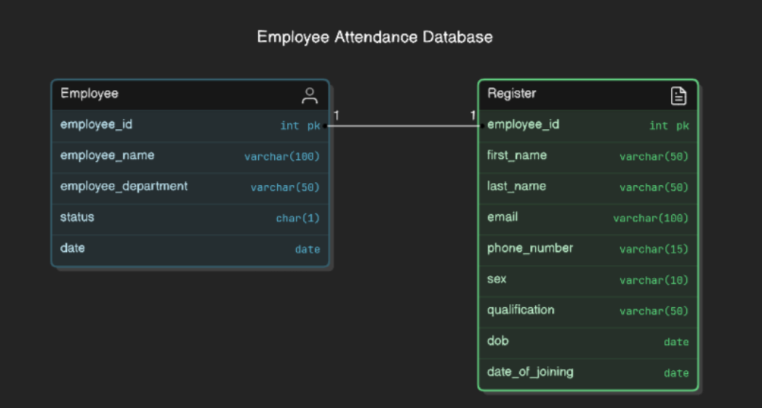

**CHAPTER 5:RESULT**

1)Login Page:

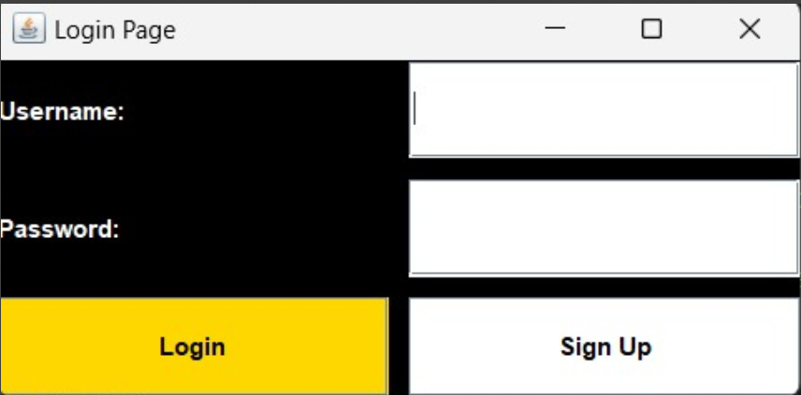

2)Home Page

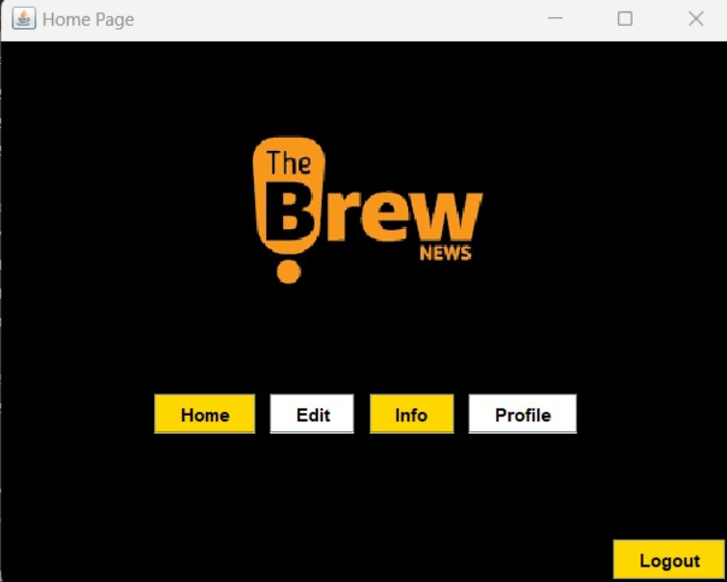

3)Edit Page

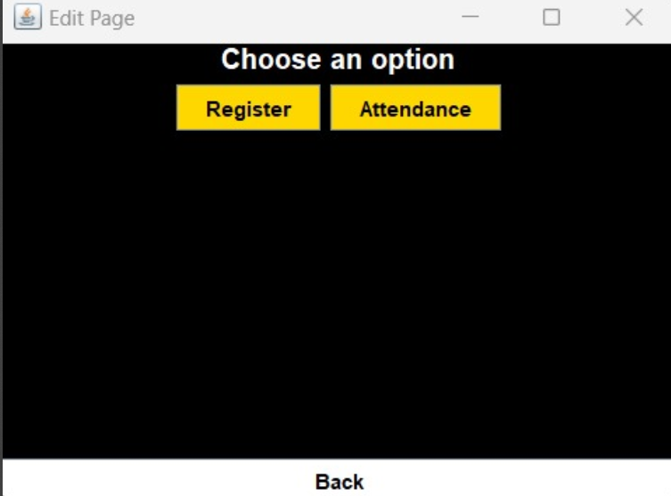

4)Register page

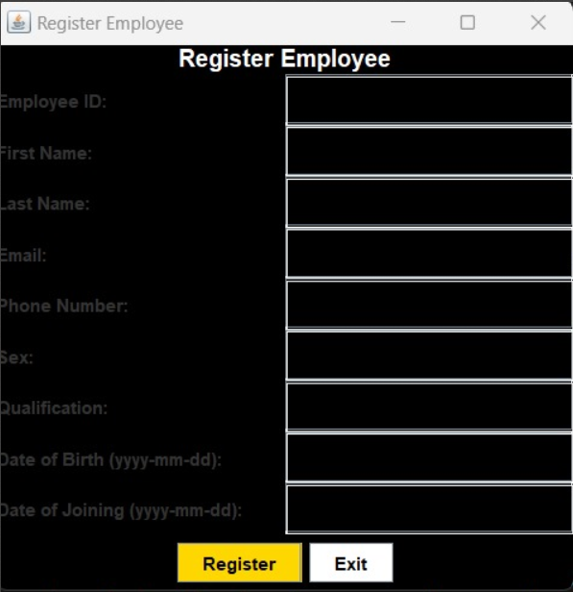

4)Attendance page

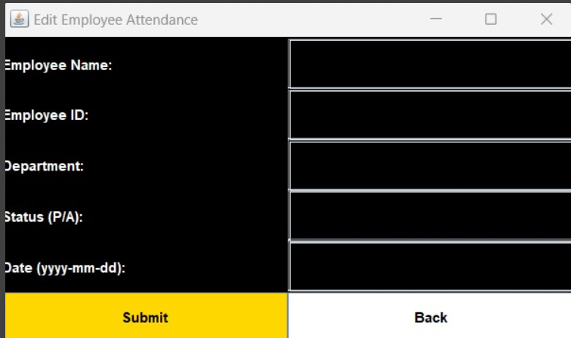

**Conclusion:**

The Brew News Website - Employee Management System provides an efficient and reliable solution for managing employee attendance and information. The system combines a Java-based front end with an SQL database for smooth data handling and a seamless user experience. With a secure login feature, employees can access the platform to mark attendance and update their personal information.

This system reduces the need for manual tracking, minimizing errors and saving valuable time for both employees and administrators. By offering modules like Home, Login, Profile, Attendance, Info, and Edit, the system ensures a comprehensive approach to employee management.

The use of Java ensures a responsive and interactive user interface, while the SQL database guarantees accurate data storage and quick retrieval. The platform is designed to be easy to use, making it suitable for small to medium-sized organizations.

Overall, the project demonstrates how modern technologies can streamline administrative processes, improving efficiency and reducing manual workloads. This system is scalable and adaptable, capable of supporting organizational growth while ensuring that employee data and attendance are managed effectively. The Brew News Website serves as an ideal solution to the needs of businesses looking to automate meet and optimize their attendance and information management processes.

Top of Form

Bottom of Form